FOCP ASSIGNMENT 1

MODULE 1
Ques 1
Read from STDIN, Write to STDOUT

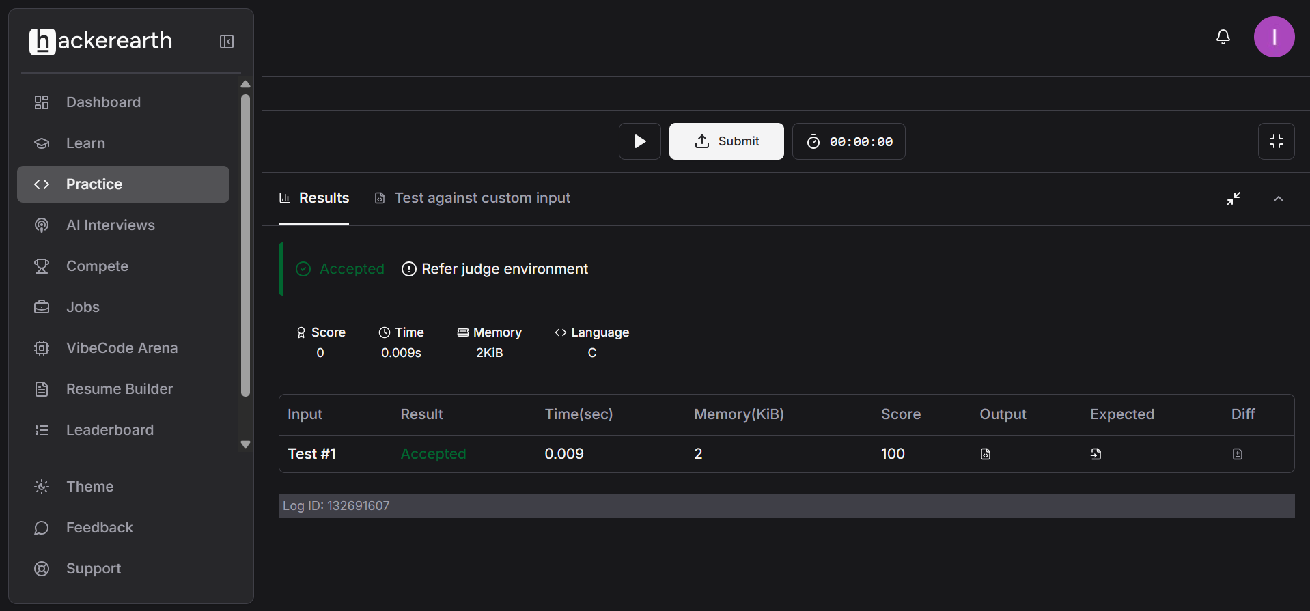

#include <stdio.h>

int main() {
int N;

char S[20];

scanf("%d", &N);
scanf("%s", S);

printf("%d\n", N * 2);
printf("%s\n", S);

return 0;
}

